Functioning of the information security management system

Topic of the lecture
Principles of construction and functioning of information security management systems. Centralized management of security policies, organizational levels of responsibility, protection architecture for heterogeneous networks of the organization.

Purpose of the lecture
Understand how the information security management system is built and works in practice. To see that there is no magic here — there are clear principles, a hierarchy of decision-making, and a well-coordinated security architecture. As a result of the lecture, you will understand how a single administrator can manage the security policies of hundreds of machines, without repeating the same work again on each device.

Main questions of the lecture
- What exactly should an information security management system provide and under what conditions does it work
- Nine principles on which the entire information security house stands
- What the real architecture looks like: Trusted Agent, GSM Server, management console
- Authentication methods-from a password to a smart card-and how they are integrated into the system
- What are proxy modules and why do you need application-level access control?

Summary

Introduction
An information security management system is not a set of tools, but a coherent set of processes, policies,and technical tools that work together. When a company grows — branches open, the number of employees grows, new servers and cloud services appear — it becomes more difficult to manage security. This is where you need a management system so that you don't manage each machine separately, but set a single policy and it is automatically applied everywhere.

Operating conditions
In practice, it is important to understand the requirements for such a system. Imagine: a fire alarm system, an access control system, and a video surveillance system work on the same server. All of them should work without interfering with each other, but exchange information about critical events.
- Subsystem compatibility: the security system should not break workflows and should not conflict with other software
- Reliability requirements should be the same for all components — if one module is weak, the entire level of protection drops
- Fault tolerance: if one subsystem fails, the rest should continue to work (degraded mode is allowed)
- Centralized or decentralized management — but with clear control over who can access what
- Everything is logged: every event is logged — this is the number one requirement for auditing and investigating incidents
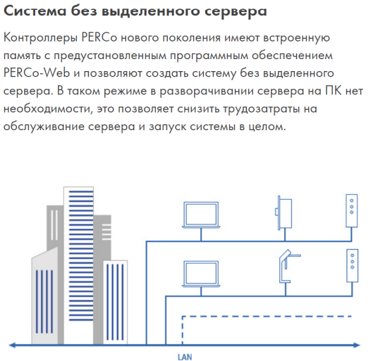
Figure 7.1. Distributed architecture without a dedicated server: controllers with built-in memory and software ensure system fault tolerance

Nine principles of organization of the information security system
These principles are the result of the experience of dozens of companies. They're not just good ideas; without them, the system will start to fail sooner or later.
Complexity. Protection is available on all floors: from the physical security of premises to data cryptography, from personnel selection policies to log auditing.
Validity. Every ruble spent on protection must be justified; we choose funds that really work and meet the standards.
Improvement. You set it up more than once and forgot it. The system lives together with the organization: new threats appear, software is updated, requirements change — the system must adapt.
Legality. All tools and procedures must work within the law; there can be no "near" legal protection.
Centralized management. A single point of policy management, but the system can be geographically distributed; an administrator in Moscow manages offices in Yekaterinburg and Kazan.
Interaction. This is not only about the company's employees, but also about cooperation with providers, authorities, and partners; the incident cannot be solved alone.
Continuity. The system works around the clock; updates and reboots are planned and performed without compromising security.
Specialization. We attract specialists who are professionals in the field of security; we do not try to solve everything with the help of one ITdepartment.

How the system works: TrustWorks example
A real information security management system consists of three key components. Imagine a factory: there are machine tools on the line (these are agents), there is a dispatcher (a management server) and a chief engineer with a tablet (an administrator console).
Trusted Agent (Local agent)
This is a program on every machine-client, server, or gateway. The agent checks who it is, blocks dangerous traffic, keeps logs, and requires authentication. Waiting for instructions from the main server.
Trusted GSM Server (Management Server)
Stores all your organization's security policies. In addition, it automatically converts the general policy to rules specific to each agent and sends them. Monitorif all agents are still alive. If necessary, the system can raise up to 65,535 servers to cope with a heavy load.
Trusted GSM Console (Admin Console)
Interface used by the administrator. Different administrators see different parts of the system depending on the role — the director sees the big picture, the branch employee sees only their own machines.
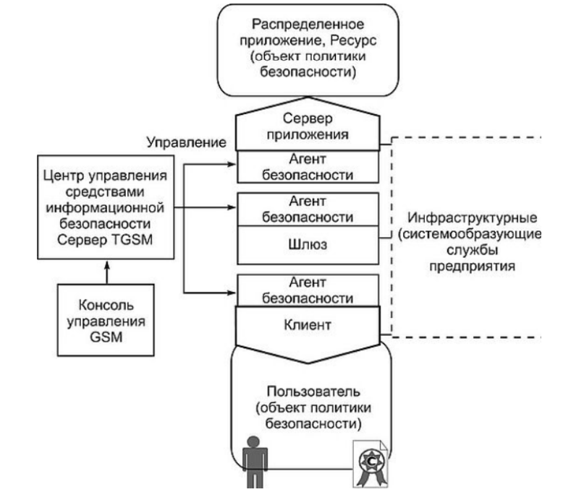
Figure 7.2. General flowchart of the information security management system

How does the system know it's really you?
The system can verify your identity in several ways, and they can be combined:
- Password-classic, familiar to everyone, but vulnerable if you choose a weak password.
- Token (physical key) - cannot be guessed or matched; if it is stolen, аварийноwe will deactivate it in an emergency.
- A smart card is a tiny computer built into the card; it stores the private key, but never gives it out.
- External authentication — the system asks another system (for example, Active Directory on your network).
- Combinations — two-factor or three-factor authentication: password + token + fingerprint.

Why is it not enough to simply authenticate
Once the system knows who you are, you still need to decide what you can do. At the network level (can your computer connect to the server at all?), and at the application level (can you see all documents or just your own).
For this purpose, proxy modules are used-special traps for requests. When you access the server, the proxy first asks: "Can you do that?" If not, it blocks it.
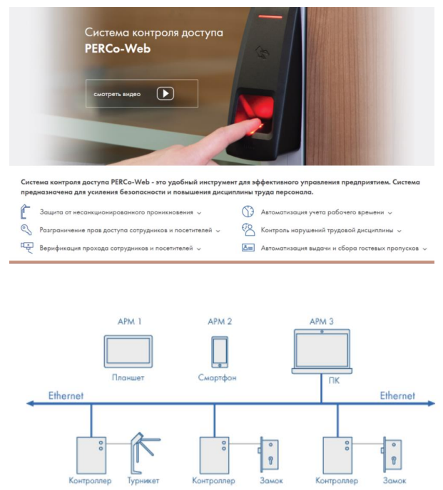
Figure 7.3. PERCo-Web access Control system: multi-factor authentication using biometrics, smart cards, and differentiation of access rights at the device and application levels

Control and Audit: see everything
Any security system is only partially technical. The second part is the people who set it up and control it. Therefore, all actions, including those of administrators, are logged.
- Event logging: every filter trigger, every access — everything is logged.
- Administrator monitoring: if an administrator has granted himself unauthorized access, this can be seen in the logs.
- Periodic audit: once a quarter or once a year, we review what has changed and why.
- Reporting: Management needs to see if there are threats and what measures have been applied.

Security questions
- Name the three main components of the information security management architecture and their roles.
- What is the difference between a Global Security Policy (GPB) and a local one?
- What authentication methods do you know and which one is the most reliable?
- Why is it important to log admin actions?
- Give an example of how a proxy module can restrict user access to application data.
- Which of the nine principles, in your opinion, is most often violated in practice and why?

List of references
- ISO/IEC 17799:2000 (BS 7799:2000). Information technology — Code of practice for information security management.
- ISO/IEC 27001:2013. Information security management systems — Requirements.
- ISO/IEC 15408 (Common Criteria). Information technology — Security techniques — Evaluation criteria for IT security.
- GOST R ISO / IEC 17799-2005. Information technologies. Safety precautions. Guide to Information Security management.
- Baranov A. S. Informatsionnaya bezopasnost': kurs lektsii [Information Security: a course of lectures]. Moscow: Akademiya, 2021.
- Gostev R. Managing security policies in corporate networks. St. Petersburg: PiterPubl., 2021.
- TrustWorks Systems. Global Security Management Concept. White paper.

